
Discovering Knowledge

COURSE: CSL 220
DATABASE MANAGEMENT SYSTEM
PROJECT REPORT
CLASS: BSE – 4C (SPRING - 2025)
PharmaCo Pharmacy Management System

Group Members

Student Name | Enrollment#
Syed Hamza Afzaal (Group Leader) | 02-131232-029
Sufiyan Maqsood | 02-131232-058
Abdullah | 02-131222-099
Muhammad Zuhair Raza Khan | 02-131232-095

Submitted to:
Course Instructor: Dr. Sohaib Ahmed
Lab Instructor: Engr. Zoobia Zeeshan

Department of Software Engineering
BAHRIA UNIVERSITY KARACHI CAMPUS

Abstract

This project aims to develop a Pharmacy Management System with functionalities for both administrators and customers. The system will maintain a centralized database for storing medicine, order, and user data. Admins can perform CRUD operations on inventory and users, view historical records, and track stock status. Customers can log in, view medicine information, and place orders. The solution will provide a simple, intuitive interface and be scalable for future enhancements like stock alerts or advanced analytics.
TABLE OF Contents
1. Introduction 4
2. Problem Statement 4
3. Proposed Solution 4
PharmaCo MS addresses these issues by offering a comprehensive web application where: 4
3.1. Features of the project 4
• User registration and login (Admin and Customer) 4
• Add/Delete/Search users 4
• Inventory management (CRUD) 4
• Product listing and management 4
• Medicine purchase and order processing 5
• Order history tracking 5
3.2. Methodology 5
We used a layered architecture pattern with a Business Logic Layer (BLL), Data Access Layer (DAL), and User Interface (UI). The project was built iteratively, starting from user management to inventory and order features. 5
3.3. Technologies 5
3.4. Block Diagram 5
4. Software Design Description 5
4.1. Design Overview 5
4.2. Work Flow Diagram 6
4.3. Use Case Diagram 8
4.4. Sequence Diagram 9
4.5. ER Diagram 10
4.6. Technologies 10
4.7. Technologies to be used 11
4.8. Screen Images 11
5. Project Scope 13
6. Module Distribution 13
7. Code 13
8. Conclusion 18
9. References 19

Introduction
In today’s fast-paced digital environment, healthcare systems demand robust and efficient solutions to manage medical inventories, track orders, and streamline user management. "PharmaCo MS" is a web-based pharmacy management system developed using ASP.NET Web Forms and SQL Server. It provides an integrated platform for administrators and customers to manage user accounts, handle inventory, list products, and process orders efficiently.

Problem Statement
Pharmacies often face issues such as poor inventory tracking, insecure login systems, inefficient user handling, and lack of integration between products and order records. Manual systems are prone to errors and lack real-time updates, which leads to stockouts, expired medicine deliveries, or customer dissatisfaction. There is a need for a centralized digital platform that provides secure, real-time access to pharmacy operations.

Proposed Solution

PharmaCo MS addresses these issues by offering a comprehensive web application where:
- Admins can manage users, inventory, and products.
- Customers can browse and purchase medicines.
- Data integrity and accessibility are ensured via a secure database.

Features of the project

User registration and login (Admin and Customer)

Add/Delete/Search users

Inventory management (CRUD)

Product listing and management

Medicine purchase and order processing

Order history tracking

Methodology

We used a layered architecture pattern with a Business Logic Layer (BLL), Data Access Layer (DAL), and User Interface (UI). The project was built iteratively, starting from user management to inventory and order features.

Technologies
• ASP.NET Web Forms (Frontend)
• C# (Backend logic)
• SQL Server (Database)

Block Diagram
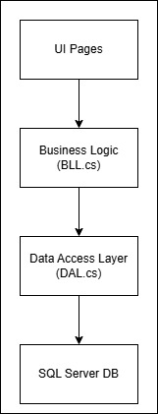

Software Design Description

Design Overview
The application uses a 3-tier architecture:
- Presentation Layer: ASPX pages (UI)
- Business Logic Layer: Handles processing, validation, and inter-module operations
- Data Access Layer: Interacts with SQL Server database

Work Flow Diagram
Admin workflow
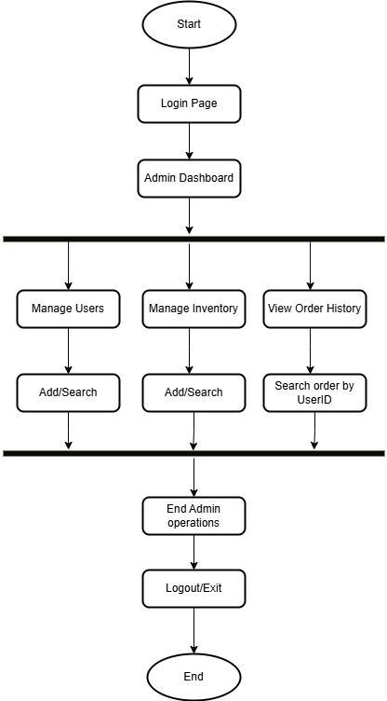

Customer workflow
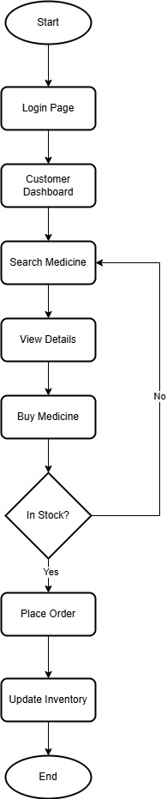

Use Case Diagram
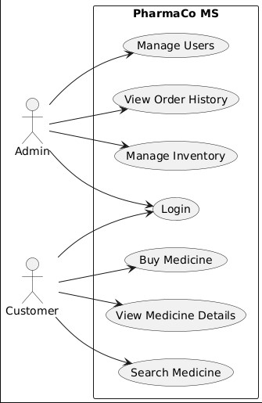

Sequence Diagram
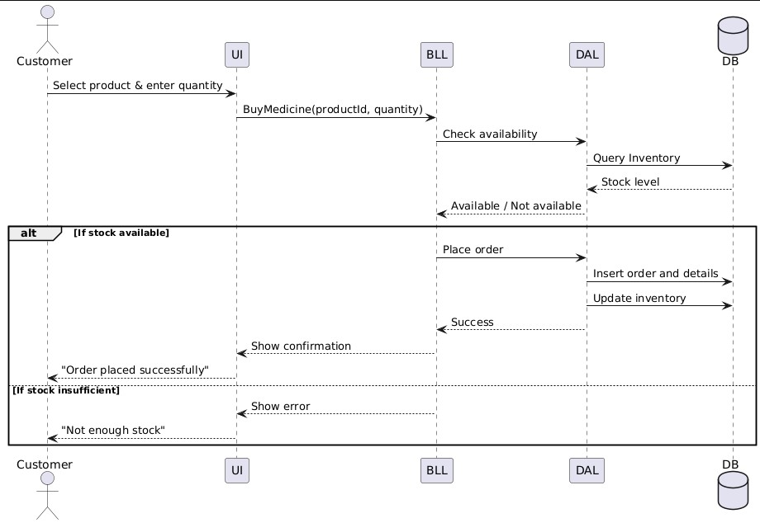

ER Diagram
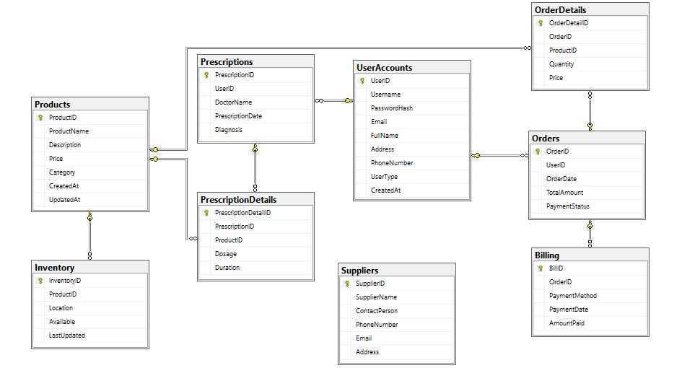

Technologies
• ASP.NET Web Forms (Frontend)
• C# (Backend logic)
• SQL Server (Database)

Technologies to be used
Frontend: Markup & Styling:
• HTML5: To create semantic and accessible web pages.
• CSS3 & SCSS: For modern, maintainable, and responsive UI designs.
Backend:
• C#: A robust and widely used backend language for scalable web applications.
• Microsoft Visual Studio: A platform to develop and design applications.
Database:
• SQL: Provides properties of scalability and flexibility in database design.
• Microsoft SQL Server Management Studio: offers a method of maintaining structured data and is also very good at managing complex relationships between tenants, property listings, and transactions

Screen Images
Login
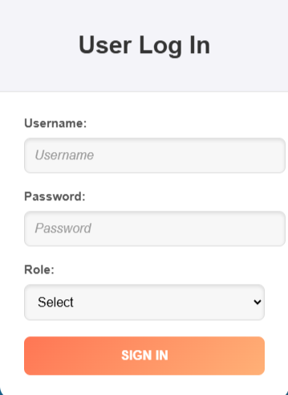
Admin Dashboard
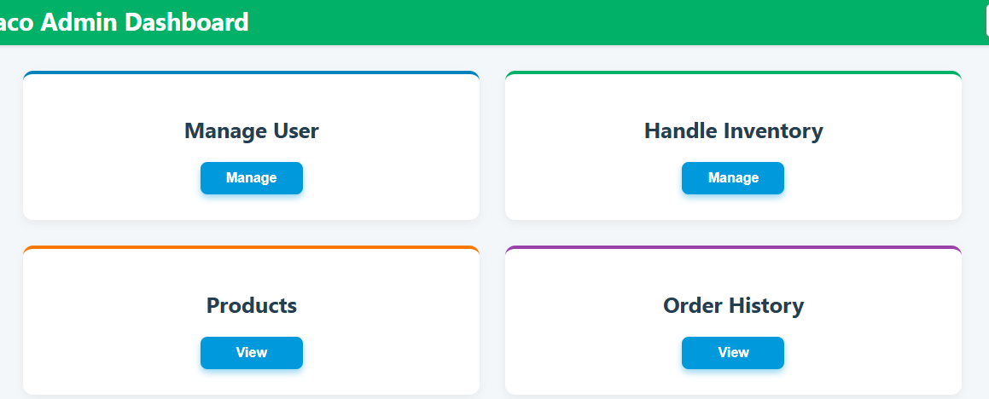
Manage User
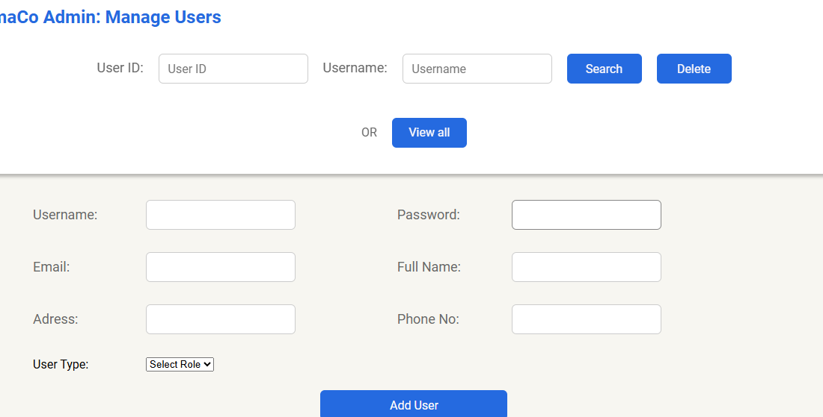
Order History
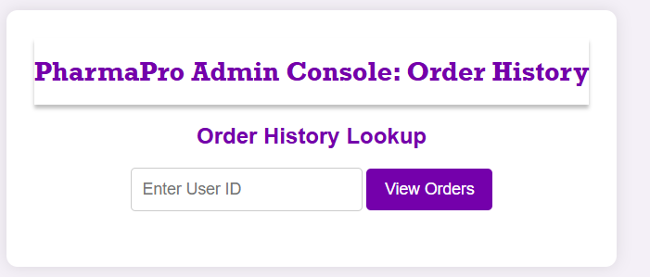
Search Medicine


Project Scope
PharmaCo MS is designed to handle essential operations in a pharmacy setting, including:
- User account management
- Inventory and stock control
- Medicine purchases and order processing
- Role-based access for Admins and Customers

Module Distribution
• Syed Hamza Afzaal (TL): User Authentication, Inventory and User Management
• Zuhair: Order and Product Management
• Abdullah: Medicine Search and Purchase
• Sufiyan: Database Design and Backend Integration

Code
using System;
using System.Data.SqlClient; using System.Data;
using System.Security.Cryptography; using System.Text;

namespace DataAccessLayer
{
public class DAL
{
private readonly DatabaseConnect dbc;

public DAL()
{
dbc = new DatabaseConnect("Data Source=DESKTOP-6LTR4JP\\SQLEXPRESS;Initial Catalog=PharmaPro;Integrated Security=True");
}
public bool VerifyUser(string username, string password, string userType)
{
bool isValid = false;

using (SqlConnection conn = dbc.GetConnection())
{
conn.Open();
string query = @"SELECT Username, PasswordHash
FROM UserAccounts
WHERE Username = @Username
AND UserType = @UserType";

SqlCommand cmd = new SqlCommand(query, conn); cmd.Parameters.AddWithValue("@Username", username); cmd.Parameters.AddWithValue("@UserType", userType);

SqlDataAdapter adapter = new SqlDataAdapter(cmd);
DataTable dataTable = new DataTable(); adapter.Fill(dataTable);

if (dataTable.Rows.Count == 1)
{
string storedPassword = dataTable.Rows[0]["PasswordHash"].ToString();

if (storedPassword == password)
{
isValid = true;
}
}
}

return isValid;
}
}
public class UserManager
{
private readonly DatabaseConnect dbc;

public UserManager()
{
dbc = new DatabaseConnect("Data Source=DESKTOP-6LTR4JP\\SQLEXPRESS;Initial Catalog=PharmaPro;Integrated Security=True");
}
public DataTable viewall()
{
SqlConnection conn = dbc.GetConnection();
SqlDataAdapter adapter = new SqlDataAdapter("SELECT * FROM vw_UserDetails", conn);
DataTable dt = new DataTable(); adapter.Fill(dt);
return dt;
}
public DataTable search(int id, string user)
{
SqlConnection conn = dbc.GetConnection();
SqlDataAdapter adp = new SqlDataAdapter(
"SELECT * FROM UserAccounts WHERE UserID = @id OR Username = @user", conn); adp.SelectCommand.Parameters.AddWithValue("@id", id); adp.SelectCommand.Parameters.AddWithValue("@user", user);
DataTable dt = new DataTable(); adp.Fill(dt); return dt;
}
public void Deleteuser(int id)
{
SqlConnection conn = dbc.GetConnection(); conn.Open();
string query = "DELETE FROM UserAccounts WHERE UserID = @UserId"; using (SqlCommand cmd = new SqlCommand(query, conn))
{
cmd.Parameters.AddWithValue("@UserId", id); cmd.ExecuteNonQuery();
}
conn.Close();
}
public void AddUser(string username, string password, string email, string name, string address, string phone, string userType)
{
SqlConnection conn = dbc.GetConnection(); conn.Open();
string query = @"INSERT INTO UserAccounts
(Username, PasswordHash, Email, FullName, Address, PhoneNumber, UserType)
VALUES (@Username, @PasswordHash, @Email, @FullName, @Address, @PhoneNumber,
@UserType)";
using (SqlCommand cmd = new SqlCommand(query, conn))
{ cmd.Parameters.AddWithValue("@Username", username); cmd.Parameters.AddWithValue("@PasswordHash", password); cmd.Parameters.AddWithValue("@Email", email); cmd.Parameters.AddWithValue("@FullName", name); cmd.Parameters.AddWithValue("@Address", address); cmd.Parameters.AddWithValue("@PhoneNumber", phone); cmd.Parameters.AddWithValue("@UserType", userType); cmd.ExecuteNonQuery();
}
conn.Close();
}
public bool VerifyUser(string username, string password, string userType)
{
SqlConnection conn = dbc.GetConnection(); conn.Open();
string query = @"SELECT PasswordHash
FROM UserAccounts
WHERE Username = @Username AND UserType = @UserType"; using (SqlCommand cmd = new SqlCommand(query, conn))
{ cmd.Parameters.AddWithValue("@Username", username); cmd.Parameters.AddWithValue("@UserType", userType); object result = cmd.ExecuteScalar(); conn.Close();

if (result != null)
{
string storedPassword = result.ToString(); return storedPassword == password;
} }
return false;
}
}

public class InventoryManager
{
private readonly DatabaseConnect dbc;
public InventoryManager()
{
dbc = new DatabaseConnect("Data Source=DESKTOP-6LTR4JP\\SQLEXPRESS;Initial Catalog=PharmaPro;Integrated Security=True");
}

//Method For Viewing all records stored public DataTable viewall()
{
SqlConnection conn = dbc.GetConnection();
SqlDataAdapter adp = new SqlDataAdapter("SELECT * FROM UserAccounts", conn);
DataTable dt = new DataTable(); adp.Fill(dt);

return dt;
}
public DataTable viewallProducts()
{
SqlConnection conn = dbc.GetConnection();
SqlDataAdapter adapter = new SqlDataAdapter("SELECT * FROM vw_InventoryStatus", conn);
DataTable dt = new DataTable(); adapter.Fill(dt); return dt;
}

//Method to view searched record
public DataTable searchProduct(int id, string product)
{
SqlConnection conn = dbc.GetConnection();
SqlDataAdapter adp = new SqlDataAdapter("select * from Inventory where ProductID =
'" + id + "' or Productname = '" + product + "' ", conn);

DataTable dt = new DataTable(); adp.Fill(dt);

return dt;
}
public void DeleteProduct(int id)
{
SqlConnection conn = dbc.GetConnection();
conn.Open(); // Open the connection

string query = "DELETE FROM Inventory WHERE Productid = @ProductId";

using (SqlCommand cmd = new SqlCommand(query, conn))
{ cmd.Parameters.AddWithValue("@ProductId", id); cmd.ExecuteNonQuery(); // Execute the DELETE command
}

conn.Close(); // Close the connection
}

public void AddProduct(string productName, string description, decimal price, string location, bool available)
{
using (SqlConnection conn = dbc.GetConnection())
{ try {
conn.Open(); // Open the connection

string query = @"INSERT INTO Inventory (ProductName, Description, Price, Location, Available)
VALUES (@ProductName, @Description, @Price, @Location,
@Available)";

using (SqlCommand cmd = new SqlCommand(query, conn))
{
// Add parameters

cmd.Parameters.AddWithValue("@ProductName", productName); cmd.Parameters.AddWithValue("@Description", description); cmd.Parameters.AddWithValue("@Price", price);
cmd.Parameters.AddWithValue("@Location", location); cmd.Parameters.AddWithValue("@Available", available);

cmd.ExecuteNonQuery(); // Execute the INSERT command
} }
catch (Exception ex)
{
// Handle SQL exception
Console.WriteLine("SQL Error: " + ex.Message);
// Optionally, log the exception or display an error message to the user throw new Exception("An error occurred while adding the product. Please try again later.", ex); } finally {
conn.Close(); // Close the connection
}
}
}

}
//Close Class InventoryManager

Conclusion
PharmaCo MS successfully provides a centralized, secure, and efficient system for pharmacy operations. It simplifies user and inventory management and ensures seamless medicine purchases. The layered architecture improves maintainability and scalability.

References
• Microsoft Documentation – ADO.NET and ASP.NET
• W3Schools – SQL and Web Forms Tutorials.

